**PUSL2010 Analysis**

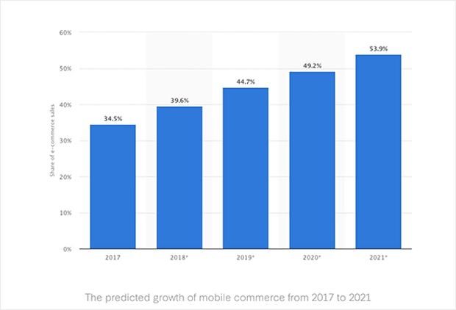As to the provide scenario in the assignment brief, this supermarket chain is planning to modernize their operations by tracking their goods’ statistics like quantity, sales rate, coordination of regional departments and to provide online shopping services. Day by day passes by the ratio of consumers buying their goods from online than attending to the store is raising gradually. So, companies should start providing their services via online to gain a profitable margin in the years to come. This interacts directly to providers like supermarket chains as they provide to extreme essentials people require daily.

*Figure 3: Illustration of Statistics Raising for Online Shopping (Ouellette, 2020)*

According to the future predictions of online shopping there will be 54% dominating the sales sector in 2021. This means half of the goods sold are either delivered to the buyer’s home or product is sent to a pick-up outlet. The main purpose for the majority interested in online shopping is due to the consumer time allocation to execute the task is less. But in terms of store shopping the instant interaction and purchase of goods is the beneficial perspective.

This supermarket chain’s main goal is to implement their own IT system and infrastructure to operate the supply chain efficiently and reliably. This brings to different perspectives in benefits and drawbacks for this supermarket chain.

Benefits:

* Data operated in the IT infrastructure is physically located under the supermarket chain’s supervision and full control over their data.
* Can instantly maintain the network and hardware equipment is necessary,
* There are less vendor limitations in further developing the IT infrastructure.
* Physical interaction to the hardware equipment will only be done by the organization’s trusted employees.

Drawbacks:

* Additional IT sector in the organization is required to monitor and maintain the network.
* More costly to run an IT infrastructure by the organization than handing over to a vendor due to the maintenance of constant usage in electricity, data bandwidth, and water. Monitoring and managing a network take a lot of resources as it’s an addition operating cycle for the organization. An IT infrastructure required for such organization requires servers, these servers are meant to be handled in certain environments like the temperature should be 19 to 24 degrees Celsius and the humidity should be at 70%. Backups systems like power back solutions, data backup solutions are required.
* High security threats and lack of experiences in handling such incidents.

These are just several benefits and drawbacks the organization would face after the installation of their own IT infrastructure.

And one drawback would be this IT infrastructure requires a tactical planning by professionals and hire skilled people to operate this new section of the daily operations. This is a crucial element as it leads to the outcome of the supply chain.

During this progression, the supermarket chain is planning to implement several functionalities,

* An option to shop online where consumers can receive the goods home delivered or collect it as a pick-up outlet.
* Quantity of goods available in the outlets and regional stores will be monitored and new stocks will be requested from the distributors.
* The monitoring and management of the supply chain will be handled by the head office of the supermarket chain 24/7.

They plan to implement such services by the use of IOT (Internet of Things) and GPS devices. Also, the security of network infrastructure will be secure as to the monitoring of the daily activities done in the supply chain.

**References**

Ouellette, C., 2020. *Online Shopping Statistics You Need To Know In 2020*. [online] OptinMonster. Available at: <https://optinmonster.com/online-shopping-statistics/> [Accessed 5 April 2020].